|  |
| --- |
| Group 1 |
| Controlled Environment Monitors |
| Manufacturing Document ( June 19 ) |

Contents

No table of contents entries found.

# Sensor Unit Manufacture

## Enclosure

Sensor Unit

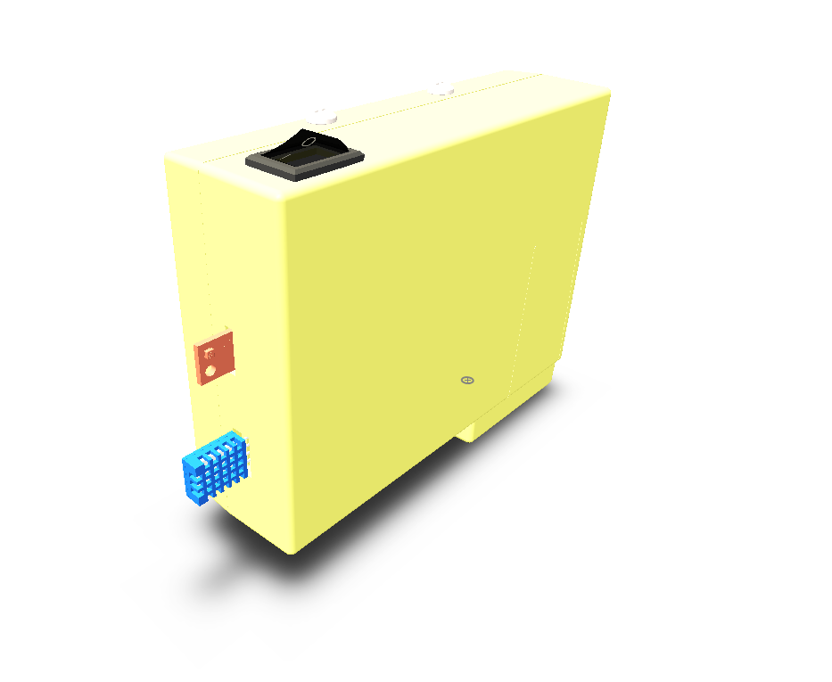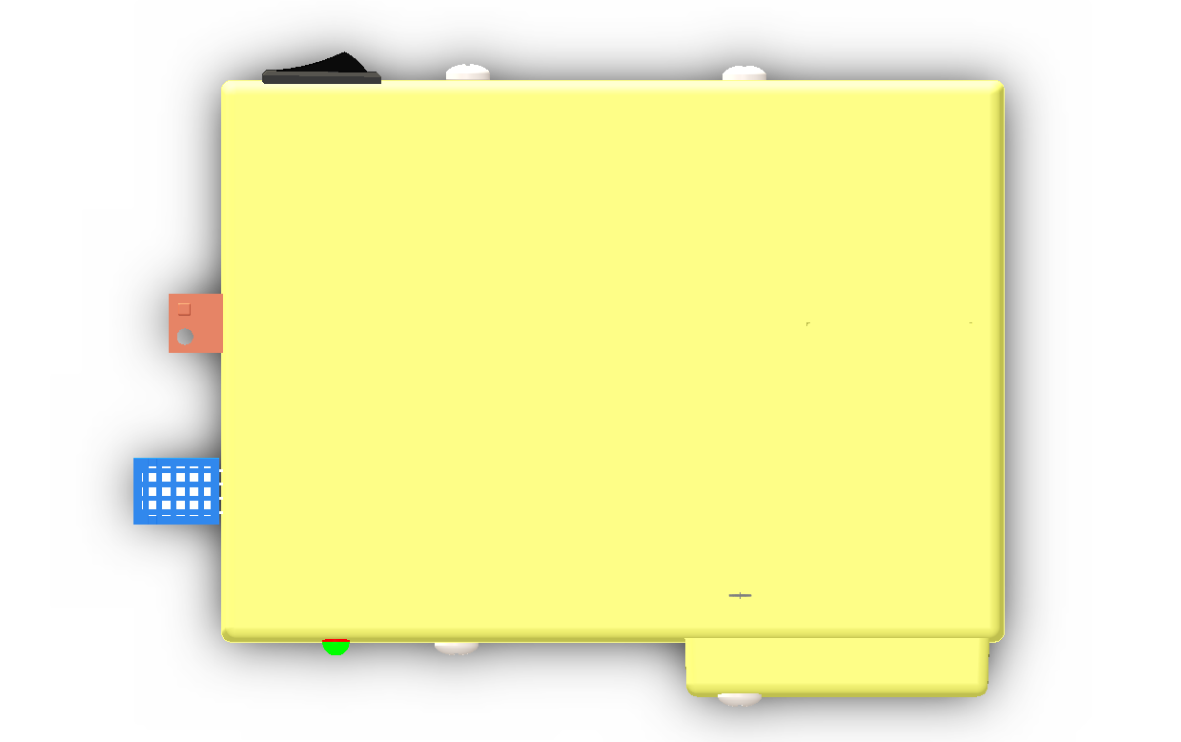

## 

### Components

The Sensor Unit Enclosure consists of 4 components that are to be manufactured by injection molding. All units are to be molded using hard plastic

Components to be molded are:

1. Top Cover
2. Bottom Cover
3. Battery Cover
4. Battery Lock

### Top Cover

#### Draft Analysis

#### Mold Components

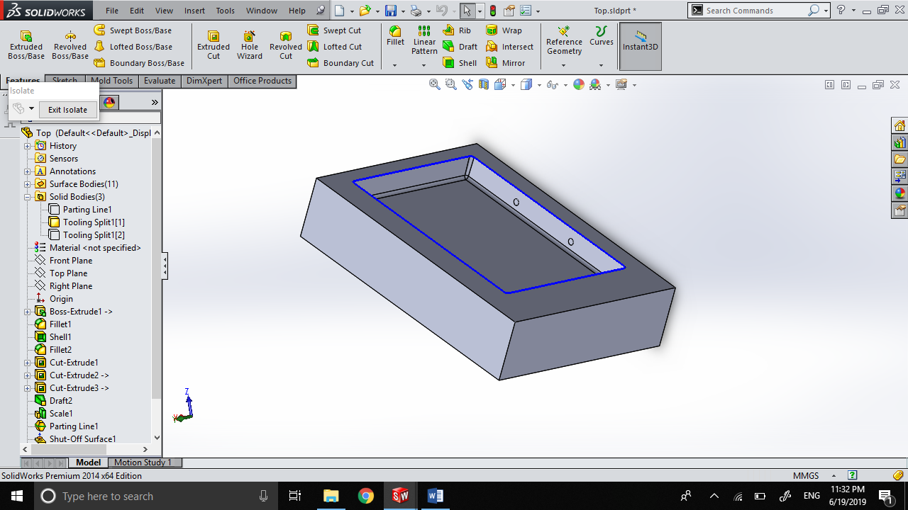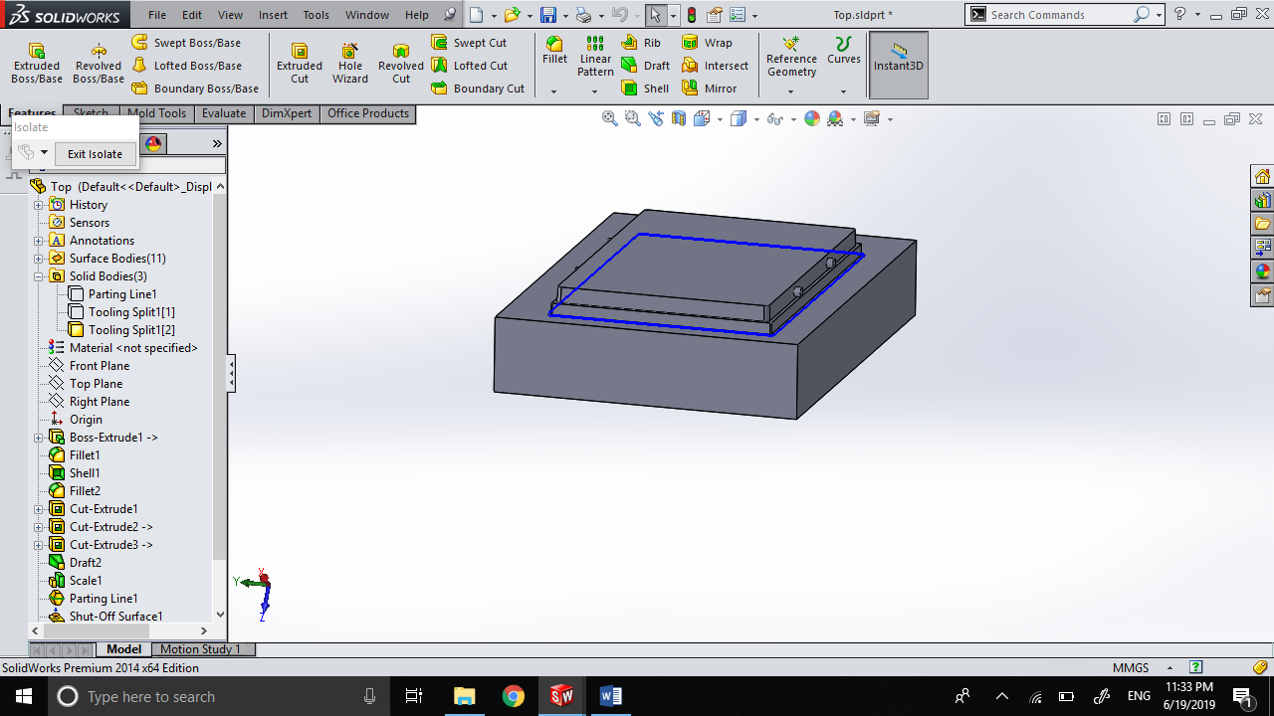

Core

Cavity

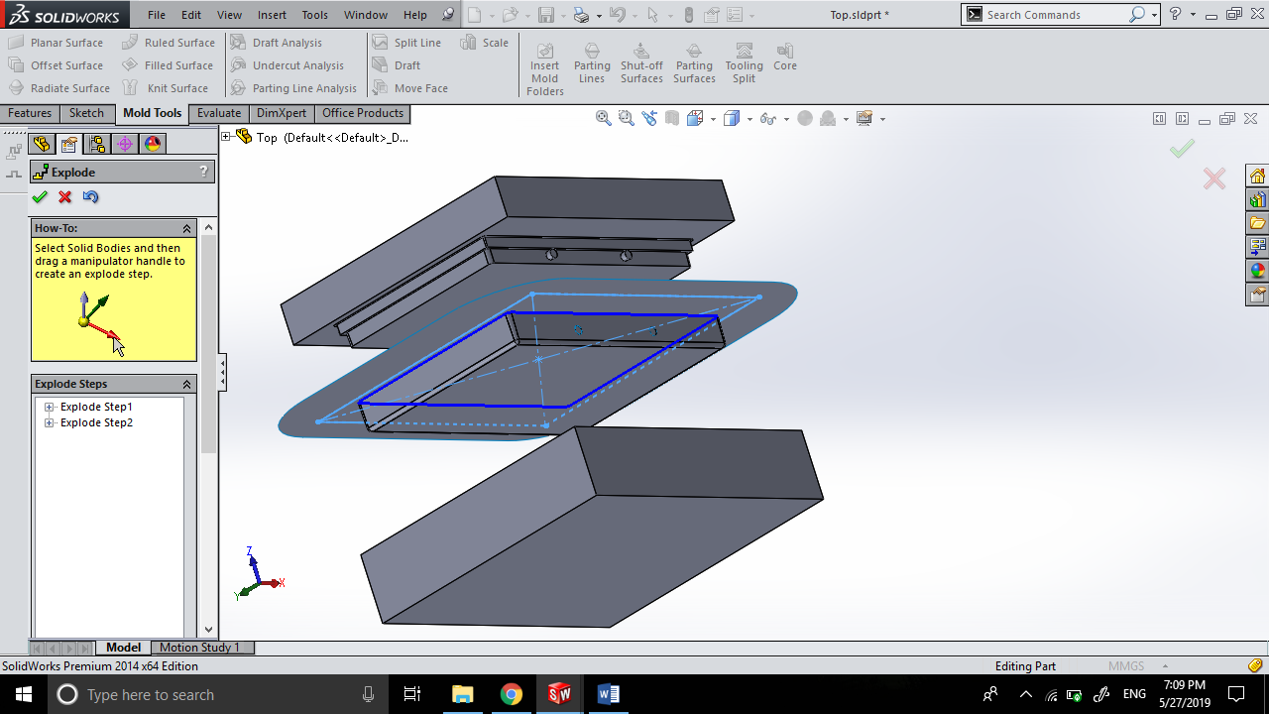

Exploded View of Mold

### Bottom Cover

#### Draft Analysis

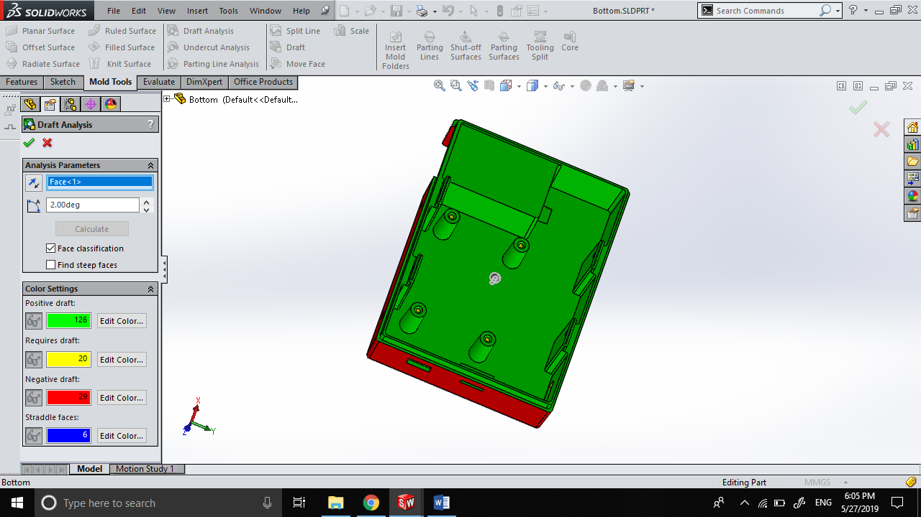

#### Mold Components

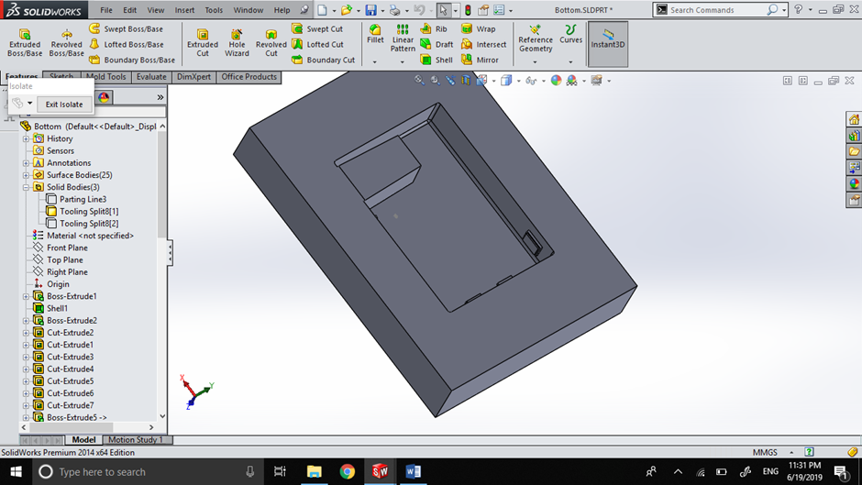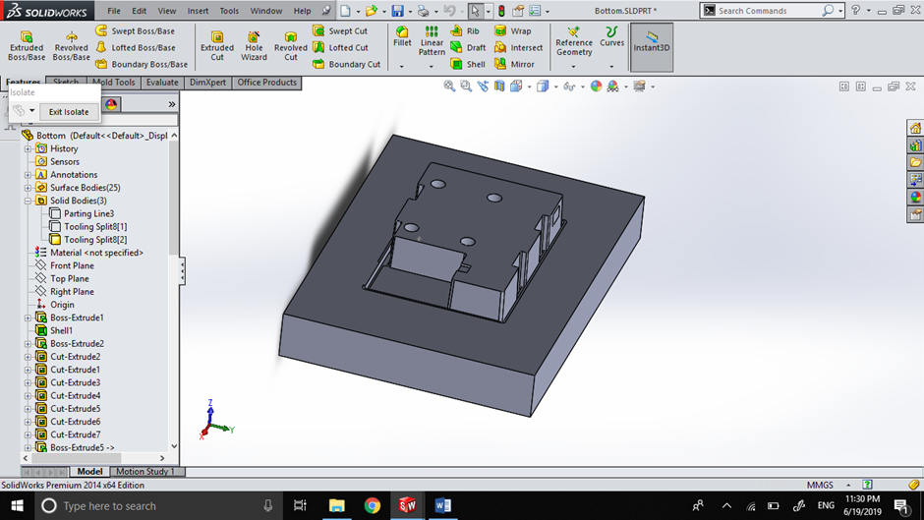

Core

Cavity

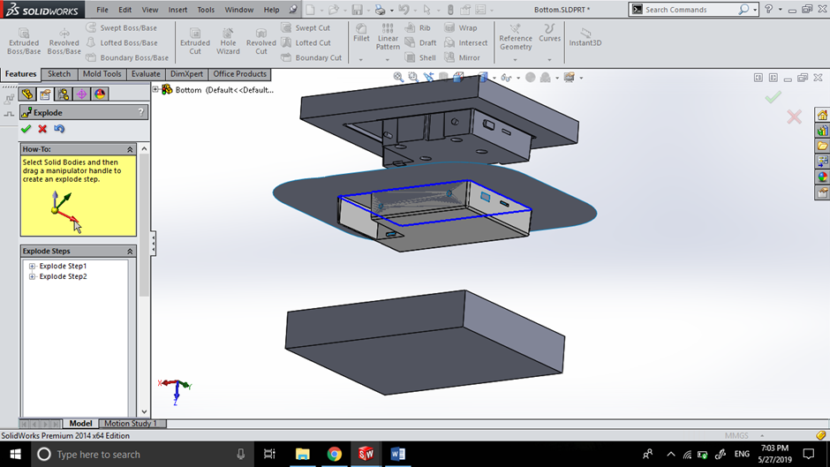

Exploded View of Mold

### Battery Cover

#### Draft Analysis

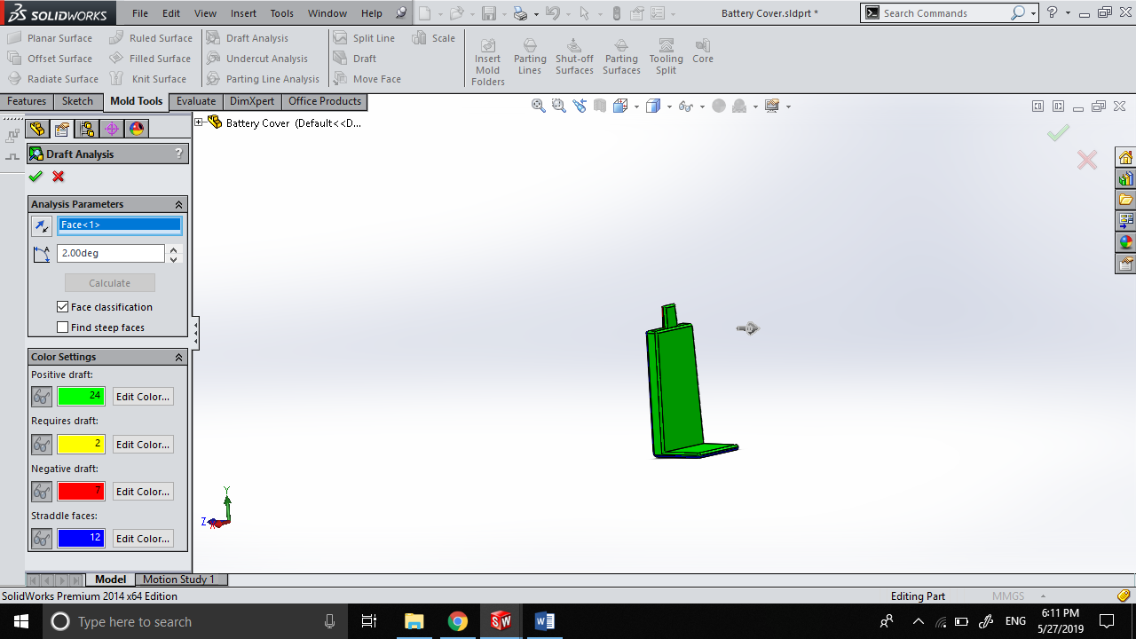

#### Mold Components

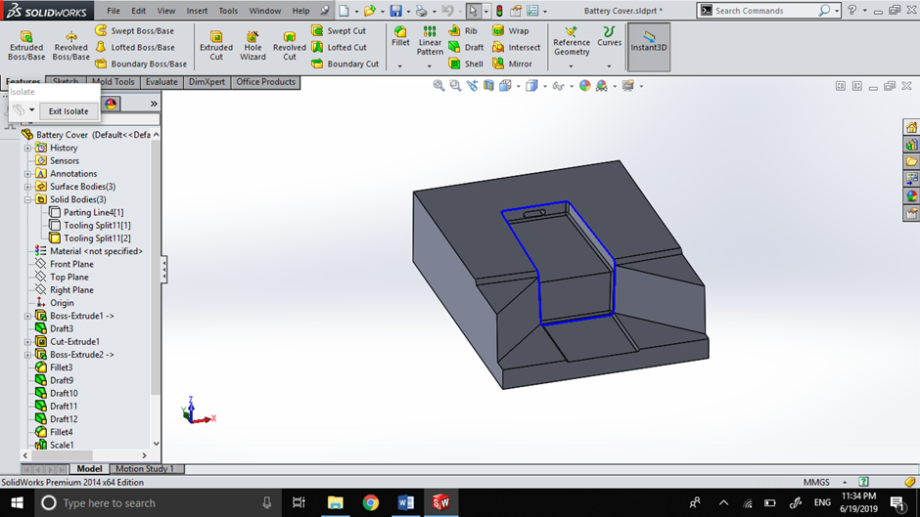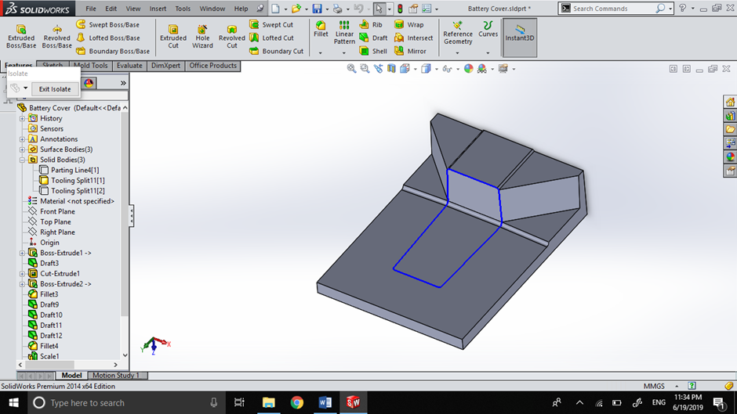

Core

Cavity

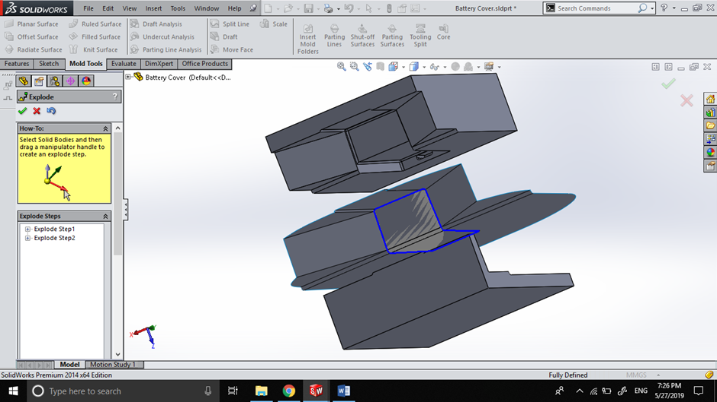

Exploded View of Mold

### Battery Lock

#### Draft Analysis

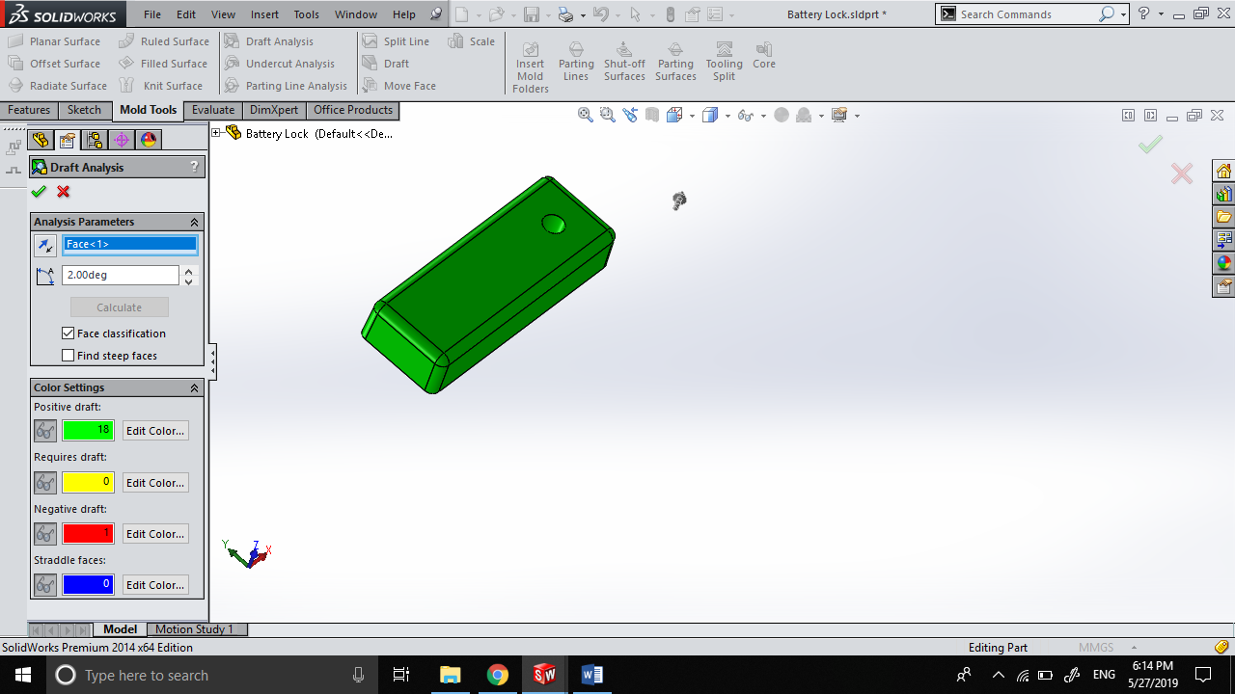

Display Unit Enclosure